WEEK -1 ASSIGNMENT (DIGITAL-NURTURE-4.0 JAVA FSE)  
Module 1: Design principles & Patterns  
Module 2: Data structures and Algorithms  
  
  
**NAME: JEYAKUMAR R  
SUPERSET ID: 6396631**   
  
**Exercise 1: Implementing the Singleton Pattern**

Logger.java:

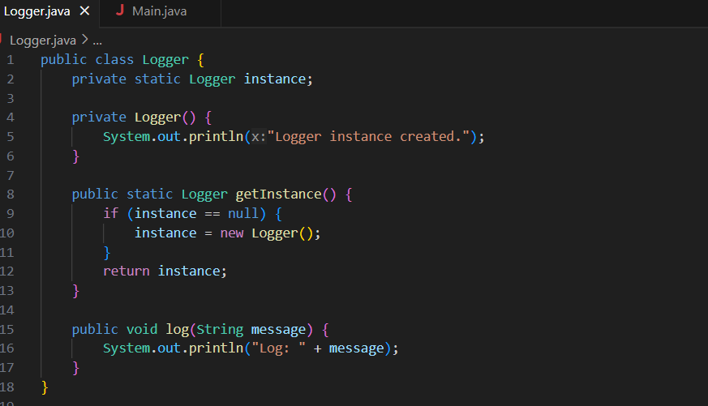

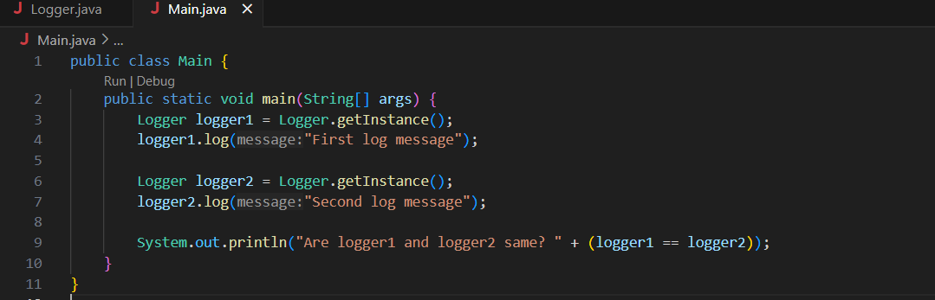Main.java:

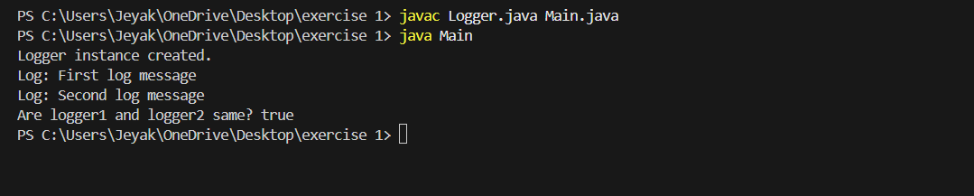Output:

**Exercise 2: Implementing the Factory Method Pattern:**  
1. Product.java  
2. SMSNotification.java  
3. EmailNotification.java  
4. NotificationFactory.java  
5. SMSNotificationFactory.java  
6. EmailNotificationFactory.java  
7. Main.java  
1. Product.java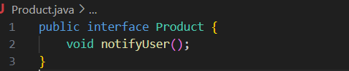

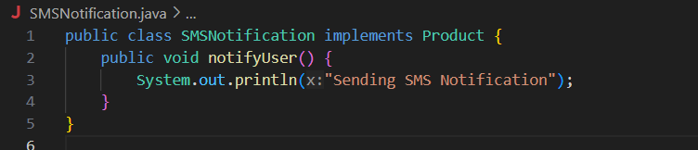2. SMSNotification.java

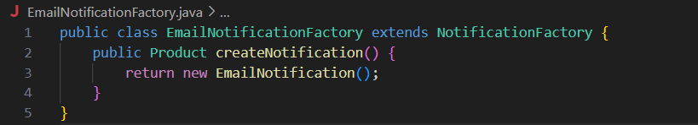3. EmailNotification.java  
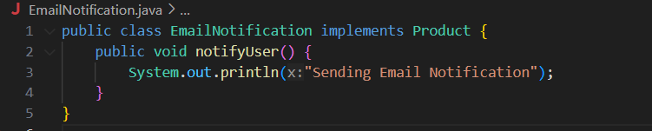  
4. NotificationFactory.java  
  
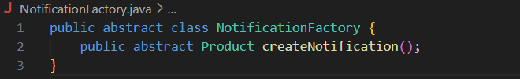  
5. SMSNotificationFactory.java  
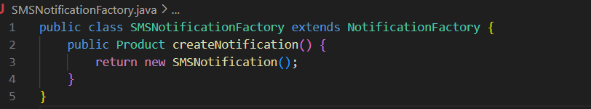  
6. EmailNotificationFactory.java

7. Main.java  
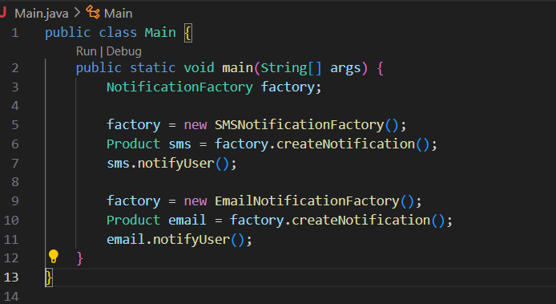

Output:  
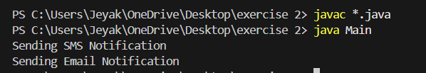   
  
**Exercise 3: E-commerce Platform Search Function**  
1. Product.java   
2. Search.java   
3. Main.java   
  
1.Product.java  
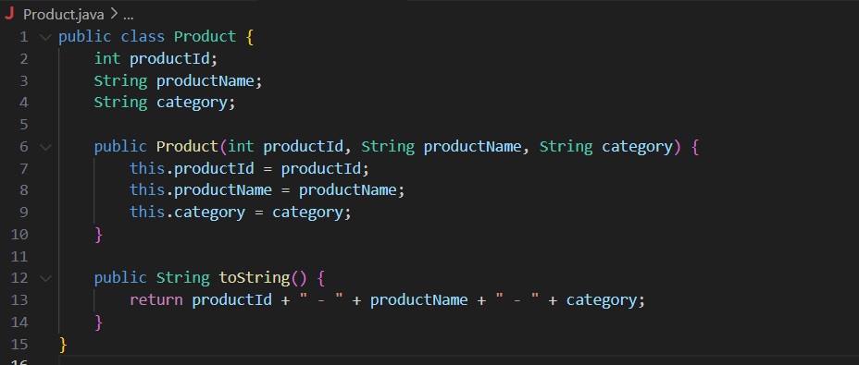2.Search.java  
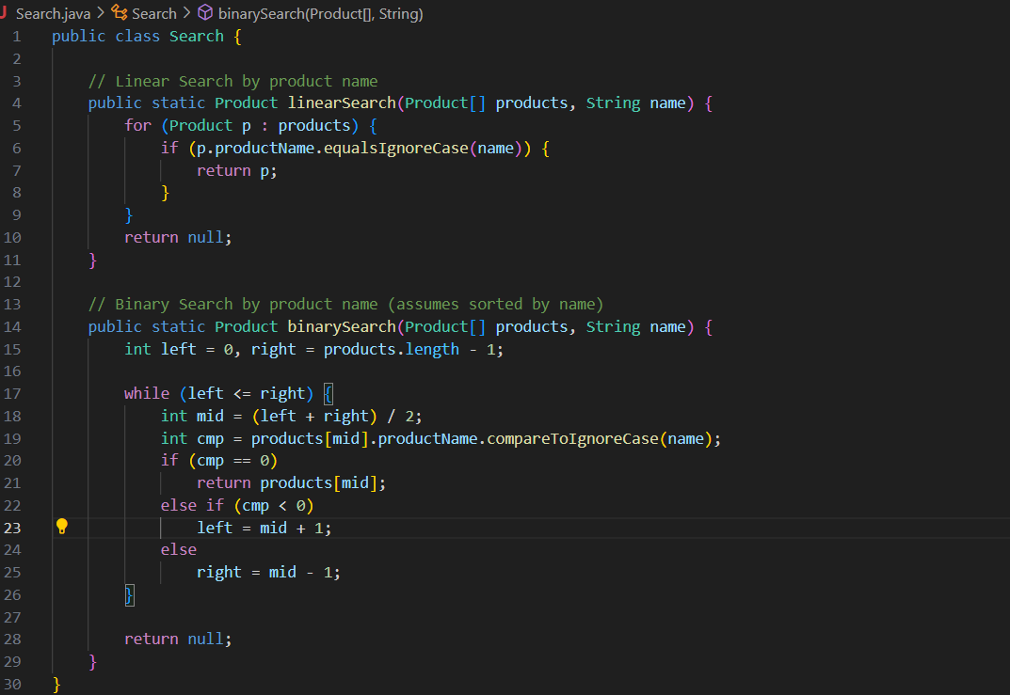   
3. Main.java   
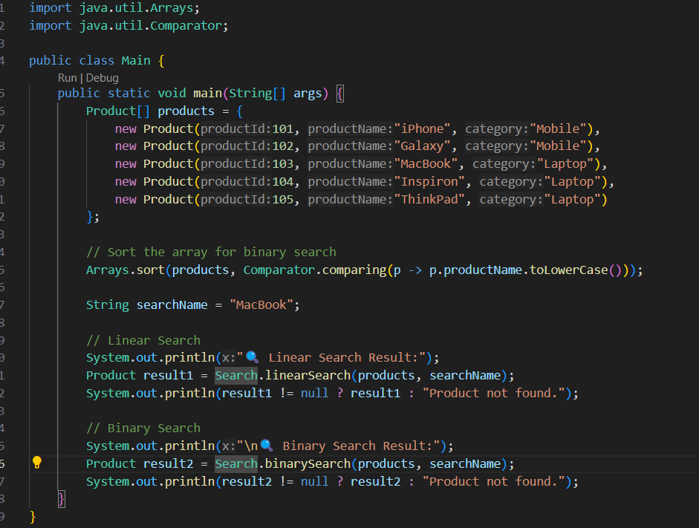

Output:  
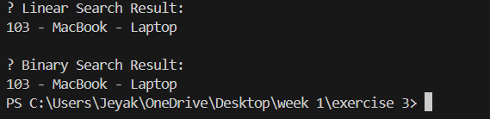

**Exercise 7: Financial Forecasting**

1. FinancialForecaster.java  
2.Main.java  
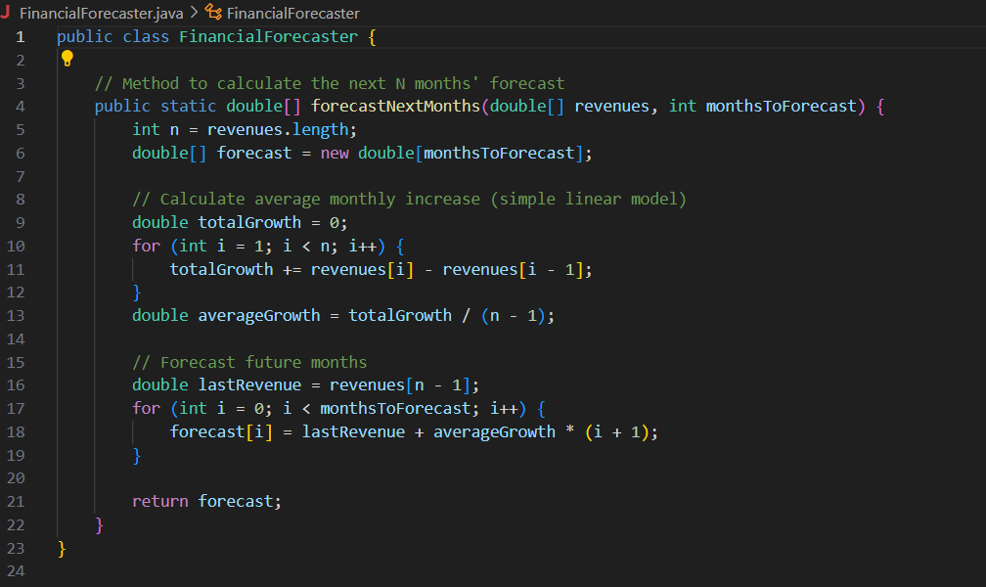Exercise 4 => FinancialForecaster.java

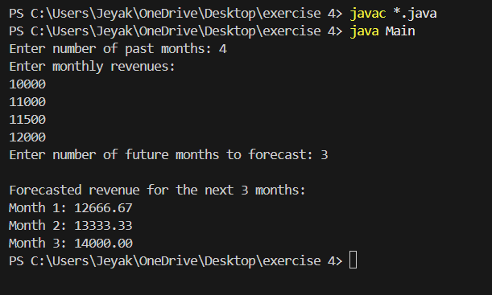2.Main.java  
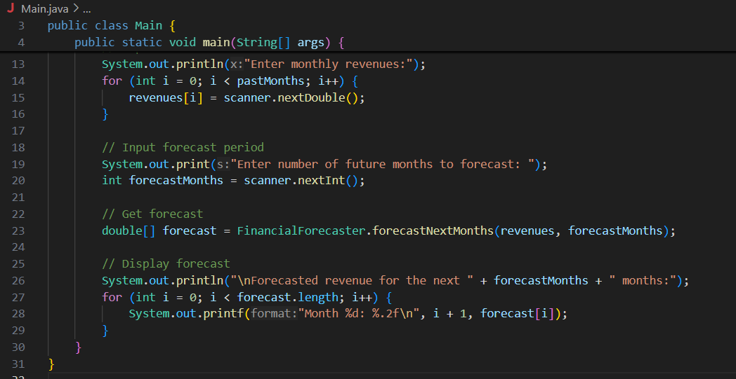o  
  
output: